John C. Coonley Elementary School’s
Young Authors’ Celebration!!
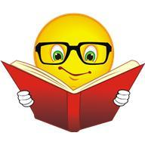When: May 21st, 2019 from 5:30 – 7:00 p.m.
Where: John C. Coonley School – 4046 N. Leavitt
Featuring the work of the Students of John C. Coonley Elementary School.
It Could Be YOU!!
First - Eighth grade students interested in sharing their story or a short excerpt of their story should arrive by 6:15 to be assigned a room. The rooms fill up fast so show up early. Readers will have a 3 minute time slot to share their story, a summary or an excerpt of it. Come out and strut your stuff. You know your story deserves an audience.
Young Author’s Celebration
Don’t want to read? You are welcome to show up anyway. You can listen to other’s stories or just read all the Young Author books on display in the MPR.
Young Author Books will be on display in the Gym or MPR from 5:30 - 7:00.
You’ll need to get yours from your classroom bin to share in a reading room. Readers should pick an age appropriate excerpt to share.

