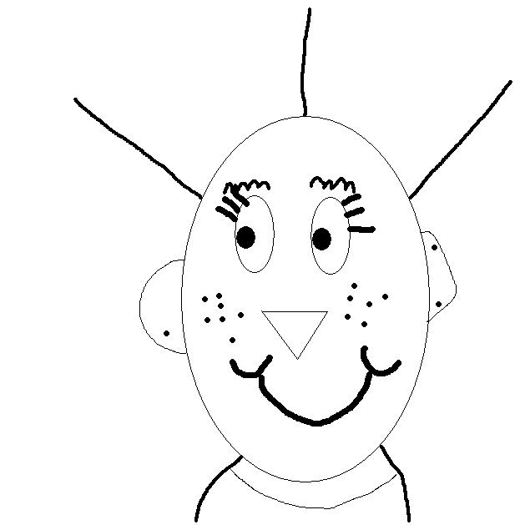
Family Homework!
(Given Tuesday 9/13, Due Monday, 9/19)

Student Name ________________________________
Sample Bioglyph

Dear Parents and Family Members,

Students are most successful in school when they can make connections between what they learn and their personal life. In order to help strengthen this connection I will be sending out family homework on a regular basis (about every two weeks). These assignments will reinforce classroom learning activities. Hopefully these assignments will be fun and engaging and lead to good conversation regarding school learning.

The first homework activity is to create a bioglyph of a family member. A bioglyph is a symbolic representation of personal traits and interests that are important in each person’s life. We are doing this activity to both build a classroom community and to gain a mathematical understanding of how symbols can be used to represent concrete concepts. The attached sheet has a key that explains what the symbols mean. In class, we made decisions about the two undecided areas. Your child has brought home these class sheets so you can include these symbols on each bioglyph.

Assignment:

Choose one family member to create a bioglyph for. Use either the male (circle) template or the female (oval) template to create the bioglyph. Add in each trait – eyes, ears, nose, mouth, etc. You need to create one bioglyph, but if you are enjoying the activity you may want to create a family bioglyph portrait.

Questions: (Answer two questions of your choosing on a separate sheet of paper.)
- What similarities do you see in your bioglyph and the bioglyphs of other family members?
- What differences do you see in your bioglyph and the bioglyphs of other family members?
- How is a bioglyph like a map?
- Did you enjoy the family homework? Why or Why not?

