Meet AUTHOR Sarah Aronson!
Sarah holds an MFA in Writing for Children and Young Adults from Vermont College of Fine Arts. She is the author of several books for young readers, including the Wish List series. She lives with her family in Evanston, Illinois. Find out more at www.saraharonson.com. She will visit our school on Thursday, May 16th. If your family would like signed, personalized copies of her work, please return this form with payment to the school library by Monday, May 13th!

Quantity |  | Title | Cost
Personalized to: | 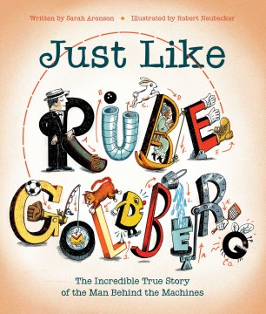  “Young readers will enjoy tracing the chain reactions for each invention and, in so doing, will be using ‘the most amazing machine in the universe: the brain!’ An engaging volume that will encourage readers to think outside the lines.” – Kirkus Reviews | Just Like Rube Goldberg  Want to become an award-winning cartoonist and inventor? Follow your dreams, just like Rube Goldberg! From a young age, Rube Goldberg had a talent for art. But his father, a German immigrant, wanted Rube to have a secure job. So, Rube went to college and became an engineer.  But Rube didn’t want to spend his life mapping sewer pipes. He wanted to follow his passion. He became known for his fantastic Rube Goldberg machines—complicated contraptions with many parts that performed a simple task in an elaborate and farfetched way. Eventually, his cartoons earned him a Pulitzer Prize and his own adjective in the dictionary. This moving biography is sure to encourage young artists and inventors to pursue their passions. | Hardcover Book  $17.65
Personalized to: | 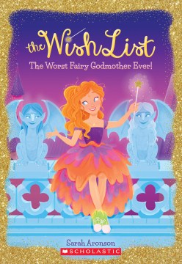 | The Worst Fairy Godmother Ever: The Wish List #1  Fairy-godmother-in-training Isabelle doesn't know what gusto is, but she's pretty sure she has what it takes to pass fairy godmother training with flying colors. But then Isabelle is assigned a practice princess who is not a princess at all. Nora is just a normal girl -- a normal girl who doesn't believe in fairy godmothers, or wishes come true, or happily ever afters. Isabelle has to change Nora's mind about magic and grant a wish for her. If she can't, Isabelle will flunk training and never become a great fairy godmother! | Paperback Book  $6.00
Thank You! | ORDERS DUE in the library by Monday,  May 13th. | Cash or Check (payable to “The Book Stall”) enclosed.  Prices reflect a 10% discount,  plus tax | Total:

Student’s Name: _______________________________ Teacher: _____________________

